

**ST. MARY’S SCHOOL SUNDERNAGAR**

**COMPUTER SCIENCE PROJECT**

**2022-23**

**SUBMITTED BY: SUBMITTED TO:**

**NAME:**  MRS.PAYAL JAMWAL

**ROLL NO.**

**CLASS: 12th**

**CERTIFICATE**

This is to certify that a student of class 12th has successfully completed their computer science project on

**“GROCERY STORE ACCOUNT MANAGEMENT SYSTEM”**

under the guidance of computer science teacher **Mrs. Payal Jamwal.**

**PRINCIPAL**

**EXTERNAL EXAMINER** **INTERNAL EXAMINER**

**ACKNOWLEDGEMENT**

In the accomplishment of this project synopsis successfully, many people have bestowed upon me their blessings and the heart pledge support, this time I am utilizing to thank all the people who have been concerned with this synopsis. Primarily I would like to thank **God** for being able to complete this synopsis with success. Then I would like to thank my Computer Science teacher **Mrs. Payal Jamwal** ma’am whose valuable guidance has been the one that helped me patch this project and make it full proof success, her suggestions and instructions have served as a major contribution towards the completion of this synopsis.

Lastly, I would like to thank **my parents** who have helped me with their valuable suggestions and support which has been very helpful in various phases.

**INDEX**

|  |
| --- |
| * Introduction |
| * About Python |
| * About MySQL |
| * Databases used |
| * Source Code |
| * Outputs |
| * Bibliography |

**Introduction**

The advent of the computer era people and businesses have found it easier to rely on electronic invoicing as an alternative to paper documents. Electronic invoicing, or e-invoicing, is a form of electronic billing to generate, store and monitor transaction-related documents between parties and ensure the terms of their agreements are fulfilled.

An invoice is a document given to the buyer by the seller to collect payment. It includes the cost of the products purchased or services rendered to the buyer. Grocery Stores needs to give a time-stamped commercial document that itemizes and records a transaction between a buyer and a seller.

E-invoicing includes several technologies and entry options and is used as a general term to describe any method by which an invoice is electronically presented to a customer for payment. Several e-invoicing standards, such as EDIFACT and UBL, have been developed around to world to facilitate adoption and efficiency.

These e-documents may include invoices and receipts, purchase orders, debit and credit notes, payment terms and instructions, and remittance slips. Advantages include the following:

* Permanence and resistance to physical damage
* Ease of searching and sorting for specific names, terms, or dates
* Increased auditability
* The ability to print or reproduce on demand
* The ability for data collection and business intelligence
* Reduction of paper use

**PYTHON**

**(FRONTEND)**

WHY PYTHON?

* Easy to read, learn and write; it has English like syntax
* Improved productivity
* Interpreted language
* Dynamically typed
* Free and open source
* Vast libraries support, portability

**SQL**

**(BACKEND)**

**WHY SQL?**

* Data security
* On-Demand Scalability
* High Performance
* Round the clock uptime
* Comprehensive transactional support
* Complete workflow control
* Reduced total cost of ownership
* The flexibility of open source

DATABASE AND TABLES:

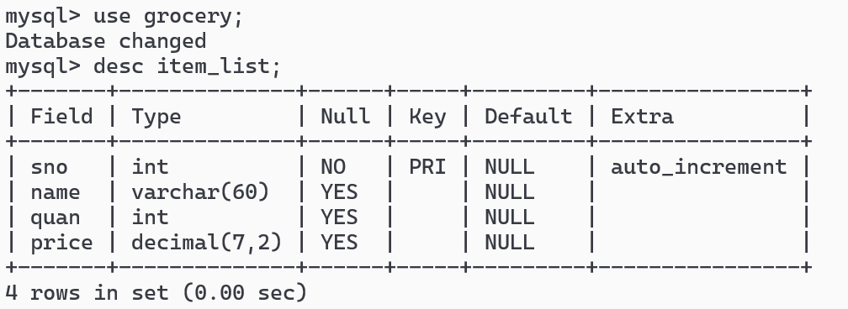

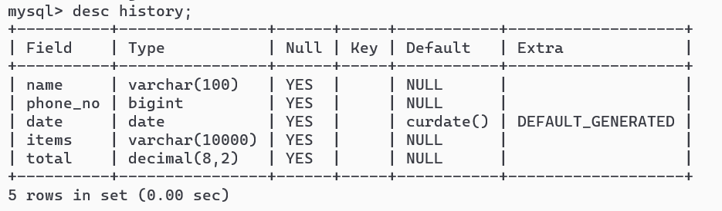

Source Code:

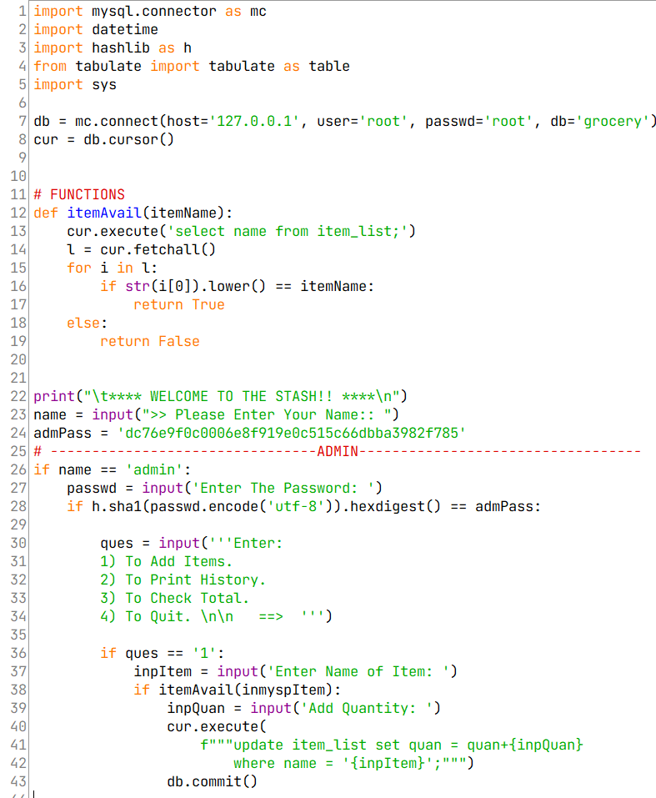

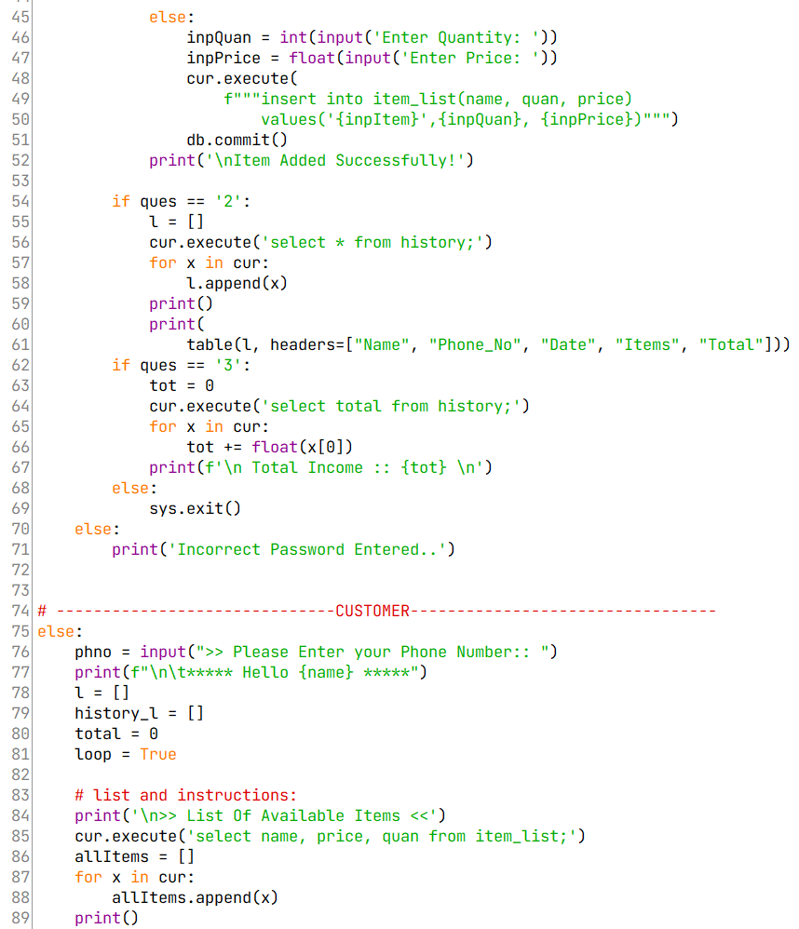

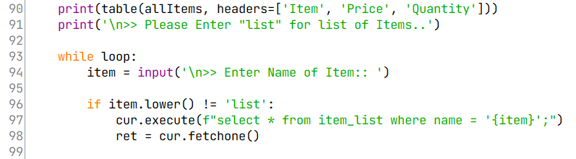

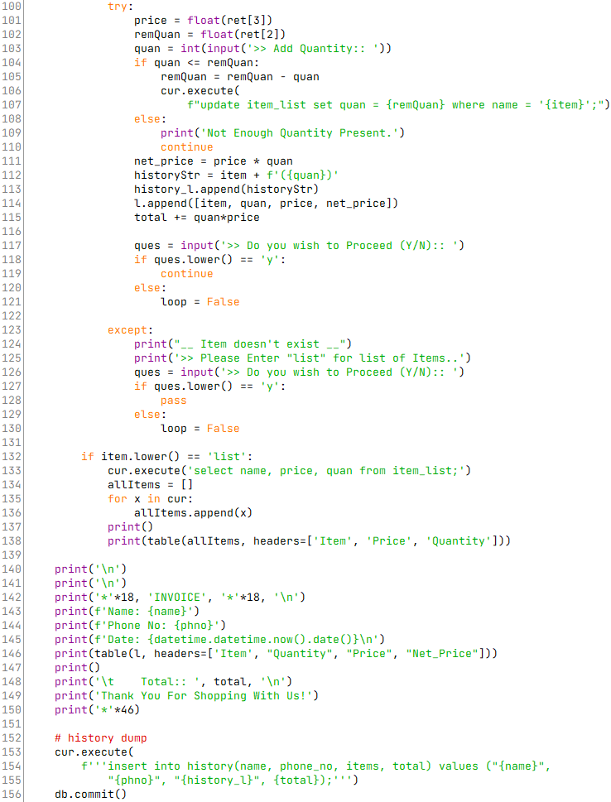

**OUTPUTS**

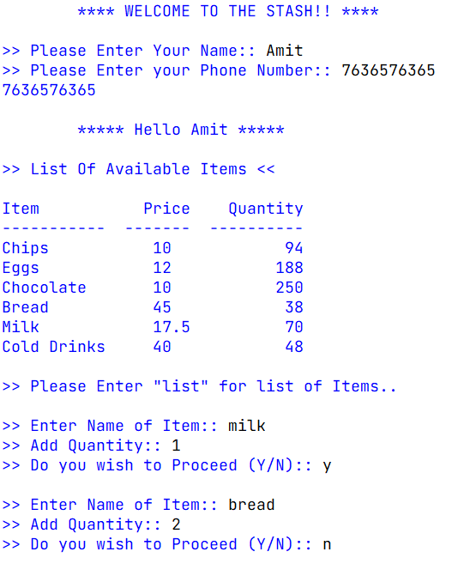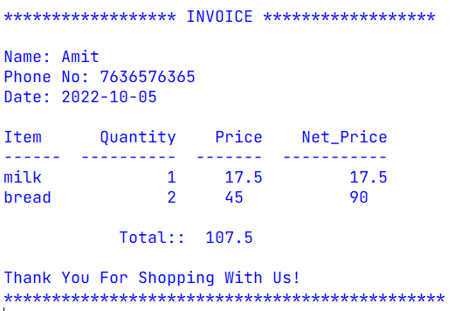

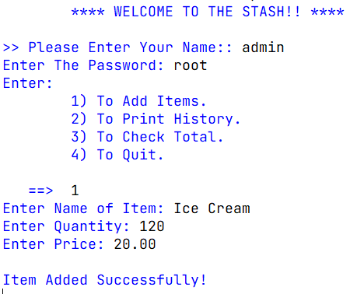

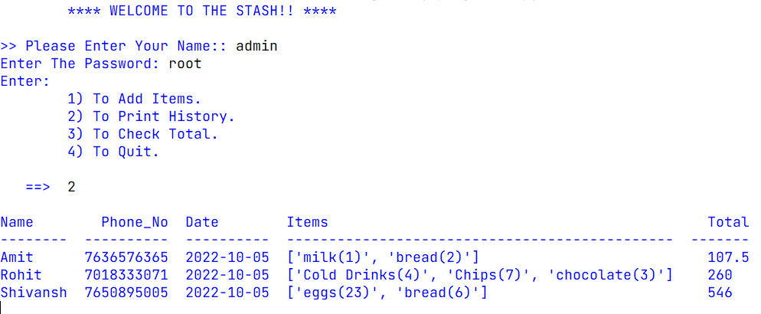

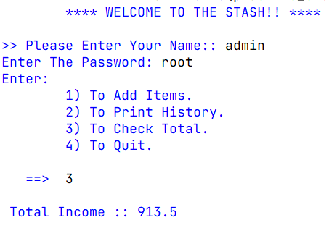**Bibliography**

* [**www.google.com**](http://www.google.com)
* **stackoverflow.com**
* **www.wikipedia.org**
* **Computer Science with Python Class 12th by Sumita Arora**

**https://www.youtube.com/watch?v=dQw4w9WgXcQ**